**Jfrog Artifactory Installation**

JFrog’s Artifactory open source project was created to speed up development cycles using binary repositories. It’s the world’s most advanced repository manager, creating a single place for teams to manage all their binary artifacts efficiently.

The below steps must be carried out to install Jfrog Artifactory.

1. Install JDK 8

yum install -y java-1.8.0-openjdk-devel

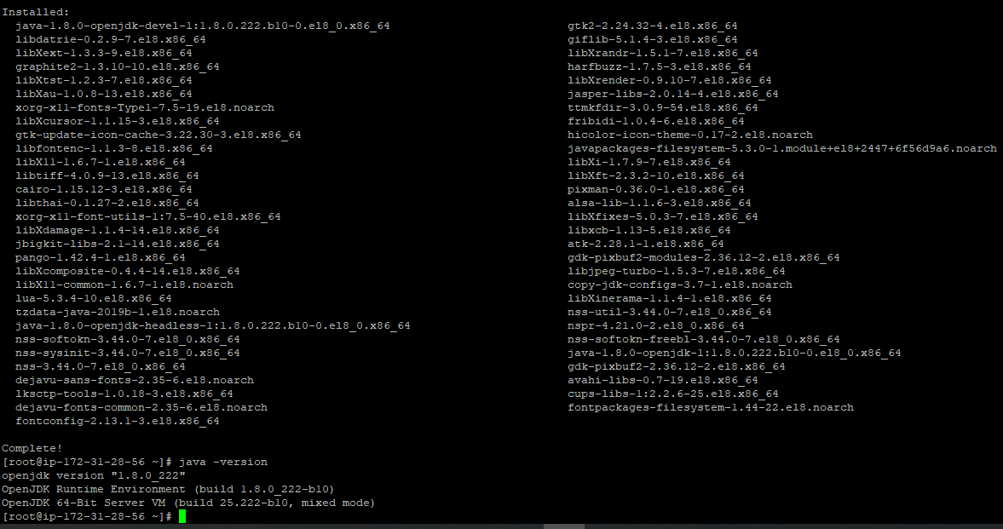

[root@ip-172-31-28-56 bin]# echo "export JAVA_HOME=/usr/lib/jvm/java-1.8.0-openjdk-1.8.0.222.b10-0.el8_0.x86_64/bin/" >> /etc/profile

[root@ip-172-31-28-56 bin]# . /etc/profile

[root@ip-172-31-28-56 bin]# env | grep JAVA

JAVA_HOME=/usr/lib/jvm/java-1.8.0-openjdk-1.8.0.222.b10-0.el8_0.x86_64/bin/

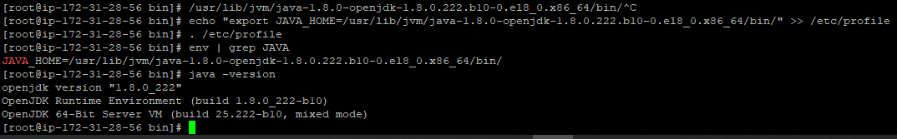

2. Install the Prerequisite Packages

yum install -y net-tools rsync

3. Download JFrog Artifactory RPM

wget <https://api.bintray.com/content/jfrog/artifactory-rpms/jfrog-artifactory-oss-$latest.rpm;bt_package=jfrog-artifactory-oss-rpm>

4. Install JFrog Artifactory

rpm -ivh jfrog-artifactory-oss-6.6.5.rpm

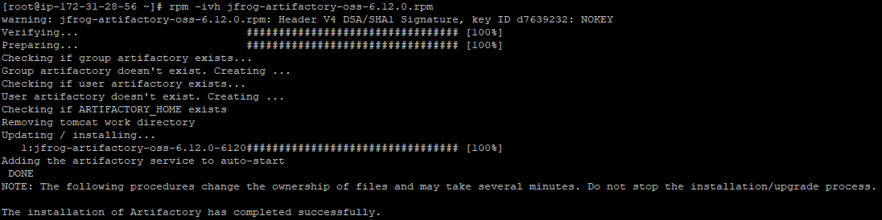

5. Set the environment variable ARTIFACTORY_HOME

[root@ip-172-31-28-56 bin]# echo "export ARTIFACTORY_HOME=/opt/jfrog/artifactory" >> /etc/profile

[root@ip-172-31-28-56 bin]# . /etc/profile

[root@ip-172-31-28-56 bin]# env | grep ARTIFACTORY_HOME

ARTIFACTORY_HOME=/opt/jfrog/artifactory

6. Start the Artifactory Service

sh $ARTIFACTORY_HOME/bin/installService.sh

7. Access the Artifactory UI from any browser as below

http://hostname:8081